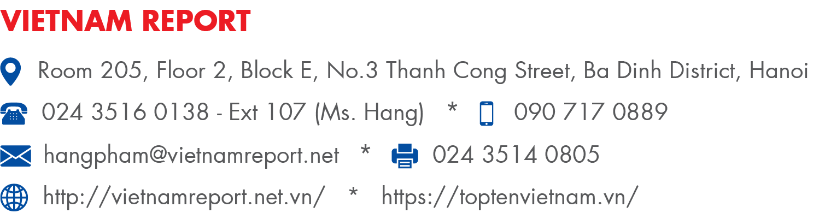 | 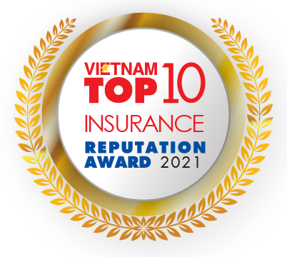

QUESTIONNAIRE
(On the rankings of Top 10 Most Reputable Insurance Companies in 2021)
All information collected will be treated with utmost discretion and confidentiality for study purpose.
Please fill out this questionnaire then send to us by 17:00 pm on June 21, 2021.
Please scan QR-code to download the questionair (if necessary).
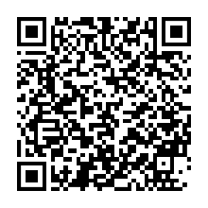
RESPONDENT INFORMATION
Full name: ………..………………………………………………………………………………………….……
Position: …………………………………………………………………………………………………………...
Mobile: ……………………………………………………………………………………………………………
Email: ………………………………………………………………………………………………….…….........
A - COMPANY'S INFORMATION

- Company Name:………………………………………………………………………………………………
- Tax code:………………………………………………………………………………………………………
- Type of operation:
State-owned enterprise
Private enterprise
Foreign-invested enterprise (with capital of foreign over 50%)
- Main business field:
Life insurance
Non-life insurance
Others (please specify):……………………………………………………………………………………...
- Financial information
Criteria | In 2020 | In Q1/2021
Total assets (VND million)
Equity (VND million)
Insurance premiums revenue (VND million)
Total revenue (VND million)
Profit before tax (VND million)
Profit after tax (VND million)

B ˗ PROSPECTS AND STRATEGIES IN THE POST-COVID-19 RECOVERY
- How would the COVID-19 pandemic affect your decision on the following operations?
 | No  change | Need to  re-evaluate | Being taking steps to change

Research and development

Customer approach

Customer journey

Risk management

Claims

Finance management

HR management

Digital transformation

Others (please specify):……………………………
- How has the COVID-19 pandemic affected your premiums by the following distribution channels?
 | Increase | No change | Decrease

Tied agents and branches

Brokers

Bancassurance

Digital: Smartphone application/ Ecommerce…

Others (please specify):……………………………
- What are your company's Top 5 priorities in the post-COVID-19 recovery?
Increase revenue
Expand operation network by opening representative offices/branches
Improve innovation capacity for product differentiation
Accelerate IT competitive advantage
Improve quality of insurance agents and consultants
Improve customer service quality
Diversify sales channels: Bancassurance, Online, Digital
Construct customer-centric operations
Restructure investment portfolio
Implement M&A
Strengthen coordination with banks, healthcare providers
Improve the quality of corporate governance according to international practices
Strengthen internal control, risk management
Strengthen claim assessment, reduce the compensation rate
Improve med-tech capability to assist public health system development
Others (please specify): …………………………………………………………………………………….
- How do you assess the impact of the following factors on your business operations in the H2 2020?
Minor impact  Major impact | 1 | 2 | 3 | 4 | 5

Internal factors

Financial capacity

Risk management capabilities

Marketing

Workforce

Management capability

Prestige, experience of leadership

Quality of products, services

Reputation of company

Development strategy

Internal investment in IT infrastructure

Co-operation with banks
Minor impact
Major impact

External factors

Macroeconomic recovery

Widespread COVID-19 outbreak risk

Demographic structure, GDP per capita

People’s awareness and education on insurance

Global integration

Competition

Legal

Technology development and Insurtech trend

Others (please specify):……………………………
- What is your assessment about the prospect of insurance companies in the H2 2020 in comparison to the H1 2020?
Pessimistic
A little pessimistic
Remain unchanged
A little optimistic
More optimistic
- What are Top 3 opportunities for Insurance industry in your opinion in the post-COVID-19 recovery?
Vietnam’s economy recovers
The finance-insurance market develops on a stable and sustainable basis
Global integration drives trade activities and markets to further
Higher GDP per capita
Low insurance penetration rate and increasing middle class
People’s better awareness and education on finance-insurance
Diverse product range
Diverse distribution system
M&A wave
Speedy technology development and its comprehensive applications in insurance value chain
Others (please specify) ……………………………………………………………………………………

- What are Top 4 challenges faced by insurance companies in the post-COVID-19 recovery?
Limited cash inflow to insurance market
Reduction in customer’s income
Weak online operation
Risks from natural disasters, serve weather, epidemics ...
Increasing competition in the industry
Lack of high-quality human resources
Lack of customers' trust on insurance products
Fraud detection and prevention
Poor IT infrastructure
Others (please specify) …………………………………………………………………………………….

- What are your Top 3 competitive advantages?
Premiums
Diverse products
Customer journey
Quality of insurance agents and consultants
Scale of customers
Distribution network and channel
Technology applications
Big data of customers and market
Others (please specify) ……………………………………………………………………………………

- In your view, in order to best support the insurance market, which of following measures should the Government focus in the near future?
Accelerate IT application
Speed ​​up restructuring, encouraging M&A activities
Continue to improve the system of relevant legal documents
Increase the level of penalties for insurance fraud
Propagandize, raise awareness of people about accident insurance, health, etc.
Others (please specify) ……………………………………………………………………………………..
- How do you assess the impact of the following factors on your company's reputation in 5-point scale?
 | 1 | 2 | 3  Minor impact  Major impact | 4 | 5

Business Capital and Performance

Customer's evaluation of the product and service quality

Evaluation about company's reputation in the media

Evaluation of experts in the industry

Evaluation of partners

Evaluation of other companies in different industries

Others (please specify):……………………………

C- INSURTECH AND DIGITAL TRANSFORMATION TREND IN THE POST-COVID-19 RECOVERY
- Have you implemented a digital transformation plan?
Already implementing
Planning to implement
Do not have plans to implement
Do not know
- What are Top 3 benefits you gain when developing Insurtech in the post-COVID-19 recovery?
Evolve customer journey
Create a platform that allows to offer superior and innovative products, for example, on-demand insurance such as: Pay-as-you-go and Pay-as-you-drive, etc.
Offer customized insurance products
Improve sales and distribution
Innovate corporate governance, enhance operational risk management
Reduce cost
Develop big data of customers and markets
Accelerate customer approach and communication capabilities
Others (please specify): ……………………………………………………………………………………..
- How is Insurtech applied to your business?
Application on smart devices
ChatBot
Online, social networking websites
Web aggregator
Peer-to-peer insurance
Core insurance software
Others (please specify): ……………………………………………………………………………………..
- What are Top 4 constraits preventing you from deploying digital transformation in general and Insurtech in particular?
Long-term investment with big cost
Internal conflicts in corporate governance, product structure transformation
Cybersecurity and customer information protection
Lack of workforce related to digital transformation: Data science, UX design, Digital marketing…
Unclear customer behavior toward online insurance trend
Lack of unique online insurance products
Face to narrow traditional insurance market in long term
Lack of regulations/policies of the government authorities
Fraud detection due to online claims
Others (please specify): …………………………………………………………………………………….
D- ACCESSMENT OF REPUTATBLE INSURANCE COMPANIES
Which are the most reputable companies in Vietnam's insurance industry in your assessment? (Please rank 1-10 for companies listed below with rank 1 as the most reputable insurance company)
- LIFE INSURANCE
Ranking | Company
 | Baoviet Life Corporation
 | Prudential Vietnam Assurance Private Limited
 | Manulife Vietnam Limited
 | AIA (Vietnam) Life Insurance Company Limited
 | Chubb Life Vietnam Insurance Company Limited
 | Prévoir Vietnam Life Insurance Company
 | Dai-ichi Life Insurance Company Limited
 | Cathay Life Insurance Company Limited
 | FWD Vietnam Life Insurance Company Limited
 | Hanwha Life Insurance Company Limited (Vietnam)
 | Vietcombank – Cardif Life Insurance Company Limited
 | Fubon Life Insurance (Vietnam) Company Limited
 | Generali Vietnam Life Insurance Company Limited
 | Aviva Vietnam Life Insurance Company Limited
 | Sun Life Insurance Company Limited
 | Phu Hung Life Insurance Joint Stock Company
 | BIDV MetLife Life Insurance Limited Liability Company

Please rank non-life insurance companies listed in the next page!
- NON-LIFE INSURANCE
Ranking | Company
 | Baoviet Insurance Corporation
 | Bao Minh Insurance Corporation
 | Petrolimex Joint Stock Insurance Company (Pjico)
 | Baolong Insurance Corporation
 | PVI Insurance Corporation
 | Baoviet Tokio Marine Insurance Company Limited
 | Union Insurance Company (UIC)
 | Post - Telecommunications Joint Stock Insurance Corporation (PTI)
 | Insurance Corporation of Vietnam Joint Stock Commercial Bank for Industry and Trade (VBI)
 | Samsung Vina Insurance Company Limited
 | Vien Dong Assurance Corporation (VASS)
 | Bank for Investment and Development of Vietnam Insurance Joint Stock Corporation (BIC)
 | AAA Assurance Corporation
 | AIG Vietnam Insurance Company Limited
 | QBE Insurance (Vietnam) Company Limited
 | Agriculture Bank Insurance Joint - Stock Corporation (ABIC)
 | Global Insurance Corporation (GIC)
 | Phu Hung Assurance Corporation (PAC)
 | Liberty Insurance Company Limited
 | Chubb Vietnam Insurance Company Limited
 | Military Insurance Corporation (MIC)
 | Vietnam National Aviation Insurance JSC (VNI)
 | Saigon - Hanoi Insurance Joint Stock Corporation (BSH)
 | Hung Vuong Assurance Joint Stock Company (BHV)
 | MSIG Insurance (Vietnam) Company Limited
 | Fubon Insurance (Vietnam) Company Limited
 | Xuan Thanh Insurance Joint Stock Corporation
 | Cathay Insurance Vietnam Company Limited
 | Groupama Insurance Company Limited

Thank you for your cooperation!

